FSDI 107 – Assignment 2
Name: Charles Taggart
Theme: First React Project
GitHub Pages Link: https://github.com/chucktagg83/project107.git
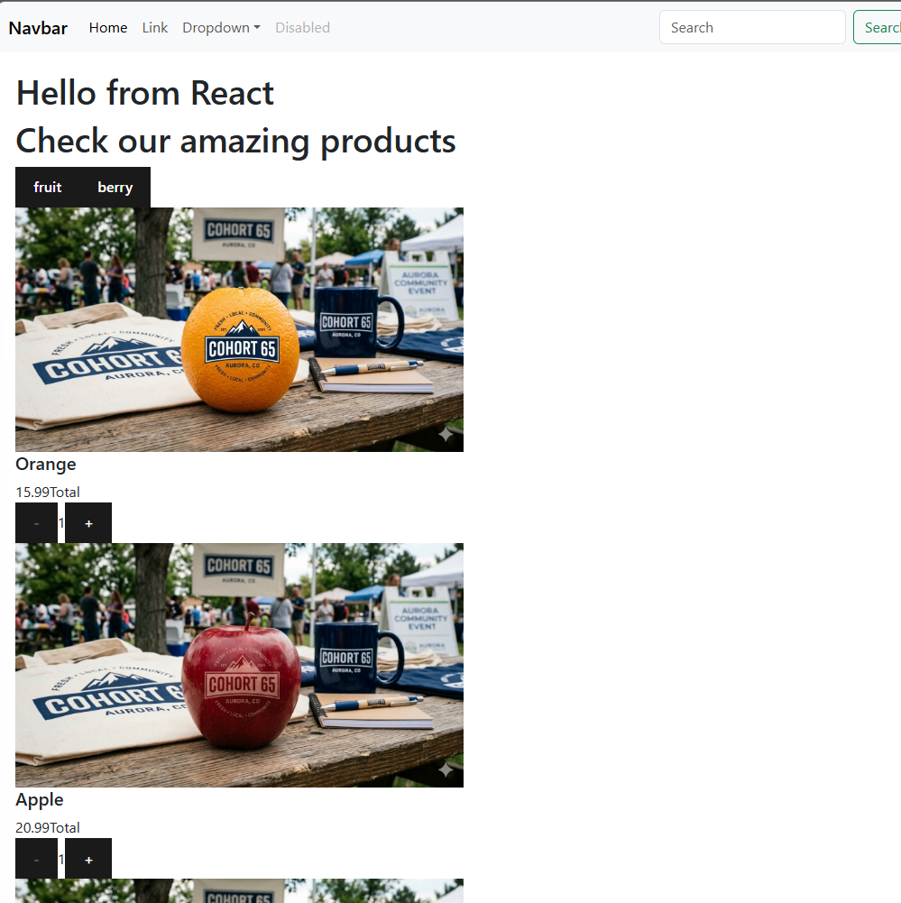

Summary of Edits:
- Navbar Component
- Quantity Picker component added
- Image, Label, and Quantity Picker all added.
- Also below is the responsiveness shown.